Antibody information (taken from antibody vial):
Product name: | Product number: | Product received:
anti- | AS | Year: Month:

Personal information:
Customer number or name:

Results are to be returned in the following format:
Description of each lane (as in the example below):
1 - xx ug of Arabidopsis thaliana whole leaf extract
2 - xx ug of Arabidopsis thaliana mutant
Mark: MW markers ; Mark MW of a target protein to be detected

Provide an IMAGE (whole membrane with MW markers), of a good quality, like in the example below:

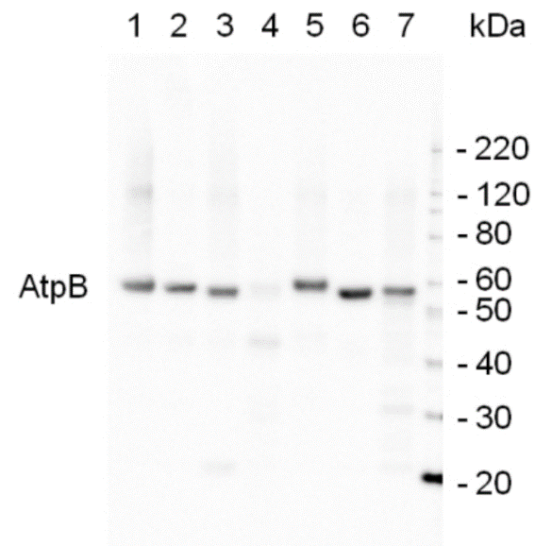

Fill in ALL experimental details marked in yellow in the template below:
? µg/well of total protein extracted freshly? from species/organ? with exact buffer components were: and denatured with exact buffer components at °C/5 or 10 min. Samples were separated on ? % SDS-PAGE and blotted for 1? h to PVDF or nitrocellulose (pore size of ? um), using: wet, semi-dry or dry transfer. Blot was blocked with ? % milk or % BSA for: 1h/RT or 4°C/ON? with agitation. Blot was incubated in the primary antibody at a dilution of 1: ? 000 for 1h/RT with agitation in TBS-T or ON/4°C with agitation. The antibody solution was decanted and the blot was rinsed briefly twice, then washed once for 15 min and 3 times for 5 min in TBS-T at RT with agitation. Blot was incubated in matching secondary antibody (anti-rabbit IgG horse radish peroxidase conjugated) diluted to 1: ? 000 in for h/RT with agitation. The blot was washed as above and developed with a following chemiluminescent detection reagent: name and supplier. Exposure time was seconds or minutes.
Questions to answer:
Was used material freshly extracted or stored?
How was primary antibody stored?
Was primary antibody or any other reagent re-used?
Was incubation volume for each step kept the same?

